PLEASE FILL THE BELOW FORM, SAVE IT ON YOUR COMPUTER AND UPLOAD
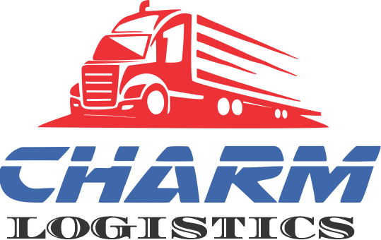 | Dispatcher:  Charm Logistics  (Charms Trend Trading LLC)  Phone: (786) 772-6602  Email: info@charmlogistics.com  Address: 28-Orange Ave  Goshen NY 10924

Equipment Information

(For multiple equipment types use the multiple truck form provided in next section)

Size, Type, Quantity, Weight Limit, Truck/ Trailer # of Trucks:
Size | Type | Quantity | Weight limit | Truck/ Trailer#
Choose an Item | Choose an Item
Choose an Item | Choose an Item
Choose an Item | Choose an Item
Custom Size? | Specialty? Write here
Comments:

Multiple Truck Form [Only fill in case of multiple equipment, o’wise please skip]
Please list your equipment and number of tractors. It will help us find you a load faster.
Vans | Qty. | VIN# / Weight Limit | Flatbed/ Specialized | Qty. | VIN# / Weight Limit
Van 48’ |  |  | Flatbed 45’
Van 53’ |  |  | Flatbed 48’
Moving van |  |  | Flatbed 53’
Van double |  |  | Flatbed B train
Van hotshot |  |  | Flatbed hotshot
Van insulated |  |  | Flatbed maxi
Van logistics |  |  | Flatbed side kits
Van open top |  |  | Landoll Trailer
Van roller bed |  |  | RGN
Van triple |  |  | RGN extendable
Van vented |  |  | Double Drop
Van blanket wrap |  |  | Stepdeck 48’
Van intermodal |  |  | Stepdeck 53’
Van lift gate |  |  | Stepdeck extendable
Van pallet exchange |  |  | Stepdeck w ramps
Van heated |  |  | Stretch trailer
Van high cube |  |  | Reefers | Qty. | VIN# / Weight Limit
Cargo van |  |  | Reefer 48’
Sprinter |  |  | Reefer 53’
Conestoga | Qty. | VIN# / Weight Limit | Reefer doubles
Curtainside |  |  | Reefer pallet exchange
Flatbed conestoga |  |  | Containers | Qty. | VIN# / Weight Limit
Stepdeck conestoga |  |  | Container 20’
Double drop conestoga |  |  | Container 40’
Dry Bulk | Qty. | VIN# / Weight Limit | Container 53’
Hopper bottom |  |  | Container insulated
Pneumatic |  |  | Container refrigerated
Belly dump |  |  | Container on flat car
End dump
Straight trucks |  |  |  | Qty. | VIN# / Weight Limit
Straight trucks less than 20 ft
Straight trucks greater than 20 ft
Other equipment |  |  |  | Qty. | VIN# / Weight Limit

Dispatch Information
We understand that many factors will change the information you give under Dispatch section, but this will
give us a starting point.
Minimum Cents ($) Per Mile: |  | Max Pick/ Pick Ups: |  | Max Deliveries:
Driver Touch: | Choose an Item |  | Preferred Distance Runs:

Zones [For Ex. NY, NJ, CT] | Preferred Routes / Lanes | Routes / Lanes to Avoid
Northeast
Midwest
Southeast
Southwest
Mountains? (Y/N)
Tolls? (Y/N)
Comments:

Insurance Company Name:
Contact Person: |  | Phone#
Comments:
Brokers you are already setup/ approved with:

Preferred Brokers | Brokers to Avoid

Driver’s First and Last Name |  | Driver’s Phone #

Carrier Pay : Payment information for mailing payments or banking info for direct deposit.
- Do you allow Advances? Choose the appropriate choice. (Mark X)
Are brokers authorized to fuel advance drivers? | Yes | X | No
Are brokers authorized to lumper advance drivers? | Yes |  | No | X

- How do you want to be paid?
Please select from the following 3 options. Complete Corresponding section below-
Mailed Check |  | Factoring | X | Direct deposit  (U.S banks Only)

Option A - Mailed Check - Input your valid remit address info.
Name of Payee:
Address:

Option B - Factoring - Input you Factoring Company’s Information.
Factoring Company Name: |  | Phone#
Email ID: |  | Fax #
Address:
Login information for Factoring Website (will be used by dispatchers to upload invoices only)
Username: |  | Password:

Option 3 - Direct Deposit/ ACH payment (U.S Banks Only).
Be sure to attach a voided check (NOT a deposit slip) from your checking account. Direct deposit will not be setup without a copy of check (or letter from banking institution stating account is active) and Federal ID / Social Security #
Your Financial Institution/ Bank Name:
City / State/ Zip : |  | FED ID / SSN#
Name of Payee:
Checking Account Number:
Bank Routing Number:

